Shuksan Teens Evaluation Report
Bridget Espinola, Vang Le, Erin Hawkins, Lauren Milne
Western Washington University
Introduction
This report is meant to evaluation the Shuksan Middle School’s Community Family Night (CFN) that took place on February 27, 2014. Shuksan Middle School (SMS) has a diverse population that is often marginalized by society. There is a prominent Spanish and ESL presence at SMS. According to the Office of Superintendent of Public Instruction ([OSPI], 2013), 53.8% of students are white, 23.3% are Hispanic/Latino, 10.7% are Asian, 11.2% are Asian/Pacific Islander, 1.8% are African-American, 1.8% are Native American, and 0.5% are Native Hawaiian/Other Pacific Islander. There are 649 students at SMS, of them 10% are in transitional bilingual programs, 3.1% are migrants, and 61.3% receive free or reduced lunch (OSPI, 2013).
Purpose
The purpose of the evaluation, evaluation questions and the evaluation plan activities is to offer recommendations on how to better develop the CFN’s efficiency in increasing student knowledge of community resources and community engagement to better improve student success. Evaluating questions helped measure whether or not students are gaining knowledge, learning about their community resources, and whether or not students are having fun with their friends, parents, and community organizations. The outcome evaluation gives an assessment of the effectiveness of the CFN in meeting student needs in order to help evaluate the event for future purposes. The evaluation plan gains constructive feedback in further developing new methods, strategies, and workshops to cultivate this high attending event where outcomes and objectives will be comprehensively studied to best meet teacher, students, and parents needs to best cater this night to its full potential.

Review of Literature
Reach for Health
In 1999, O’Donnell et al. conducted a study to evaluate the “effectiveness of a community youth service (CYS) program in reducing sexual risk behaviors among African American and Latino urban young adolescents” (p. 176). Two groups of students received two different curriculum formats - one group was taught the Reach for Health curriculum solely, while the other group was taught the Reach for Health curriculum in addition to CYS assignments (p. 177). Questionnaires were distributed to obtain baseline data, reporting that 23.1% of the respondents had sex within the last 3 months, of which 39.7% reported no or inconsistent use of condoms and 45.7% reported that they practiced no or inconsistent use of birth control (p. 178). Results showed that although more students were having sex than before, sexually active students’ neglectful use of condoms fell by 12.7% in students who were taught the standalone curriculum and 15.9% in students who practiced additional CYS assignments. Students who were previously having sex without birth control fell by 5% in students who received the curriculum and 8.4% in students who received additional CYS assignments (p. 178). The results of this study may suggest that community connections have a positive impact on a youth’s ability to make healthy decisions about their lifestyle.
Building Hope for the Future
Marques, Lopez, and Pais-Ribeiro (2011) conducted an evaluation of a 5-week intervention. This intervention was “designed to enhance hope, life satisfaction, self-worth, mental health, and academic achievement in middle school students” (p. 139). “It has been theorized that hopeful thinking reflections a transactional process” (as cited in Snyder et al., 1997; pp. 144-145), so a group setting was chosen for this study. After the program, participants in the program experienced significant increases in hope, self-worth, and satisfaction that were shown to be moderately sustained over an 18-month period (Marques, Lopez, & Pais-Ribeiro, 2011, pp. 146-149). The results of this study suggest that participating in a group setting can enhance feelings of hope and confidence in goal-setting for middle school students.
Expanding Community: Youth, Social Networking, and Schools
Stornaiuolo, DiZio, and Hellmich (2013) “examined the construct of community and its development in online spaces through . . . middle school students’ participation in a private social network” (p. 79). Students from five different middle schools met after-school twice per week to participate in a digital media program with the purpose of teaching these students effective communication skills with other students through a private social network (p. 80). Some students were slightly cautious and were sometimes rude when being solicited by a stranger, but softened up once their rudeness was pointed out (p. 80). All 59 students created their own profiles and made different posts with text, music, and picture (p. 82). The participants showed that “their willingness to reveal themselves was connected to feeling safer participating in a space in which a limited number of participants could view their online efforts” (p. 82). The authors note that the student’s exposure to each other online anchored them in a way that allowed them to build new social relationships (Stornaiuolo, DiZio, & Hellmich, 2013, p. 83). These findings show how big of a role that communication and proximity play in building community among youth.
Evaluation Activities
Initiative
SMS hosted the annual CFN event on February 27, which offered free workshops to parents and students on topics that affect today’s youth such as identity and drug use. The event was largely successful in attracting participants and delivering relevant and helpful guidance for the youth. It is important to note that school vice principal, Janae Hodge, stated that this is a community contributing event where SMS do their best to be open to all community members who want to participate (J. Hodge, personal communication). This follows through with the SMS theory of “collective impact,” where there is/are a common agenda, shared measured systems, mutually reinforcing activities, continuous communication, and having backbone support organizations. This approach is a good template for how to do a better job by working effectively together. The quality of engagement that was present at the event was moderate. Overall, the kids were very responsive to the activities as seen in the data retrieved. Feedback was given to help further instructors, workshops, and developing future curricula.
Evaluation Questions
The following are our evaluation questions:
- Did the Shuksan Family Night workshops increase knowledge among the teens?
- Did the teens learn about community resources at the event?
- Did the teens have fun with friends, parents, and community organizations?
Evaluation Activities
SMS hosted four different workshops with two sessions. These four workshops were “Embrace Your Identities”, “Youth and Marijuana: What road will you take?” “Getting around town: Bike & bus-riding tips,” and “Choose Your Own Path.” The CFN is made of collaborative efforts between SMS and many community partners including the Bellingham Police Department, Whatcom County Health Department, Communities in School, Rebound of Whatcom County, and many more providers of resources, entertainment, and connections. These sessions raised awareness and answered any questions both parents and students had about the topics at hand. Sessions also gave students opportunities to interact with their peers outside of regular school hours. The night began with dinner at 6:00PM and then proceeded into workshop sessions, booths, and open gym play. The night also consisted of connecting the community members and parents, by which they started to build a network of support and larger community.
Methodology
Participants. Participants were gathered at the workshops the teens attended. The evaluation team attended the workshops and presented surveys at the end of the sessions. Team members disclosed the purpose of the surveys and that participation was anonymous as well as voluntary. To encourage teens to participate an incentive was presented to those who completed surveys – raffle tickets. Students that completed a survey received one raffle ticket to be used towards a raffle contest that was hosted at the CFN.
Instruments. The team developed surveys to distribute for data collection. There were three surveys developed – one for session one, and two for session two. Two of the surveys are the same, both on the front side of each survey; these surveys served the purpose of evaluating the specific workshop they were distributed in. The surveys for session two had two sides to the survey; the front page was the aforementioned workshop survey. The back page was a survey that was used to evaluate the CFN as a whole. Session 1 surveys were printed on peach-colored paper, while Session 2 surveys were printed on green-colored paper. These surveys can be found under Appendix A and Appendix B.
Data collection and analysis. After the workshops ended surveys were collected and sorted into envelopes for each workshop in order to be easily coded for data entry. Once coded, survey data was entered into Microsoft Excel sheets and processed into charts for analysis. These charts can be viewed under Appendices C through K.
Results
Each set of surveys gathered from the four events had different, unique results. Beginning with Session 1 of “Embrace Your Identities,” according to the data collected, all participants were from the 6th grade.
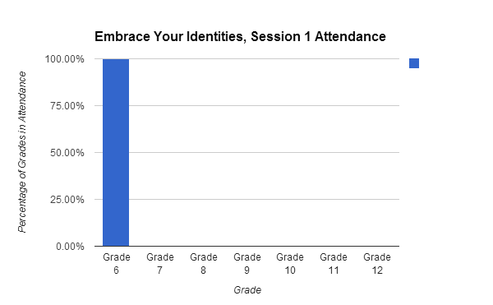
100% stated, in the survey, that they influenced themselves to attend.
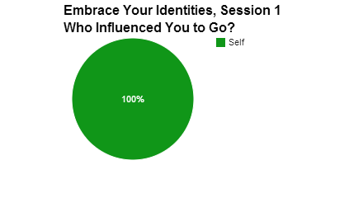
All participants also agreed that the session was “Kind of” enjoyable.
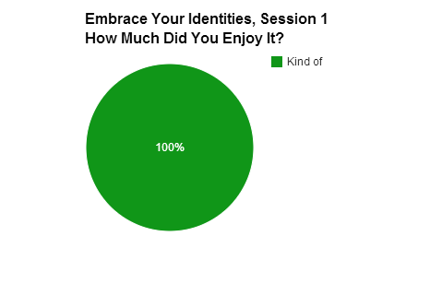
No one had any questions and all felt that they had learned something in the end.
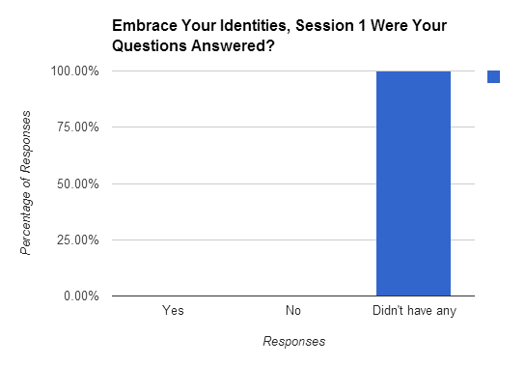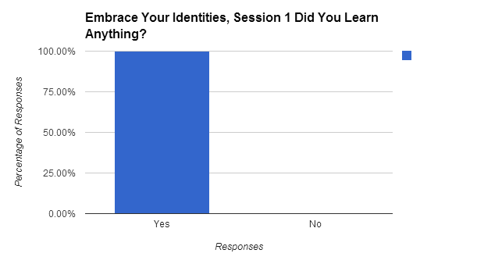
Session 2 of “Embrace Your Identities” showed much more diverse results.
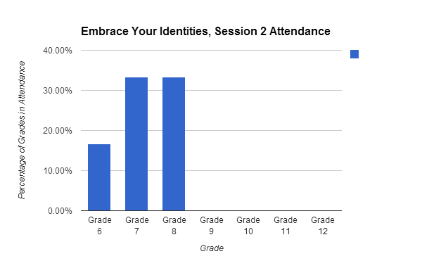
33.33% attendees were in the 8th grade, another 33.33% were 7th graders, and only 16.67% were in the 6th grade.
This particular group was also influenced to attend the session by more than their own peaked interest (only 52.9%). 41.2% were also influenced by peers and the remaining 6.9% were influenced by their teachers.
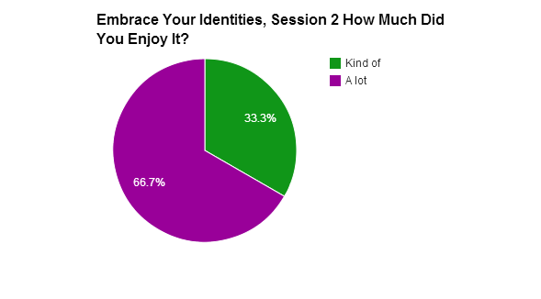
In regards to enjoyment, 66.7% stated that they enjoyed the session “A lot” and 33.3% stated that they only “kind of” enjoyed the session.
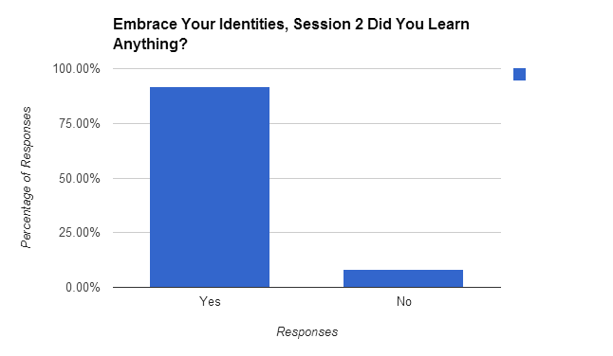
91.6% students affirmed that the session taught them something while 8.33% said otherwise.
Next, both sessions of “Youth and Marijuana” had drawn in a large spectrum of reactions.
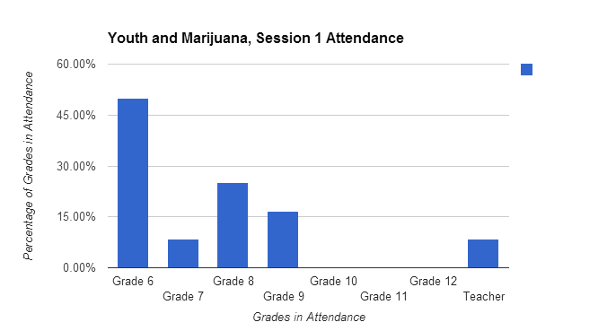
In Session 1, feedback was received from the 6th grade (50%), 7th grade (8.33%), 8th grade (25%), and 9th grade (16.67%), as well from a teacher.
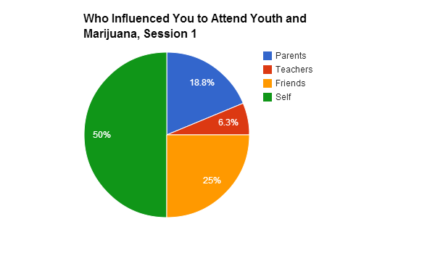
When it came to influence, personal interest affected 50% of attendees, parents encouraged 18.8% whereas teachers encourages only 6.3%, and peers/friends encouraged 25% of the students present.
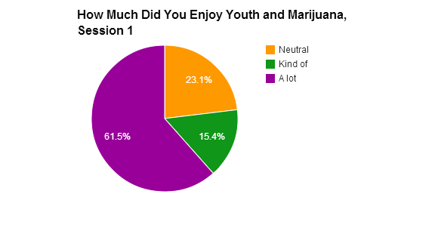
61.5% stated that they enjoyed the session “A lot”, 23.1% were “neutral”, and 15.4% only “Kind of” enjoyed the session.
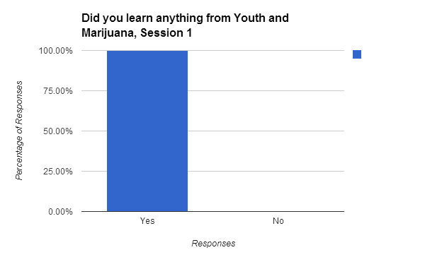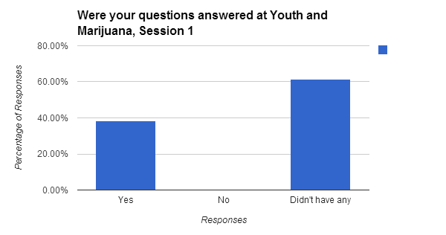
As the “Youth and Marijuana” drew to a close, all attendees stated they had learned something and 38.64% had their questions answered while 61.54% had no questions. Session 2 of “Youth and Marijuana” had diversity in different areas.
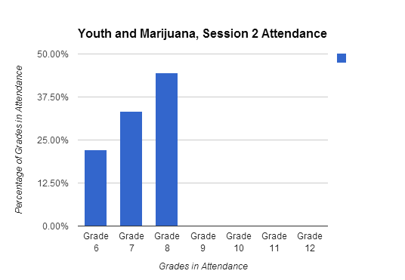
Of the 9 attendees, 22.22% were 6th graders, 33.33% were 7th graders, and 44.44% were 8th graders.
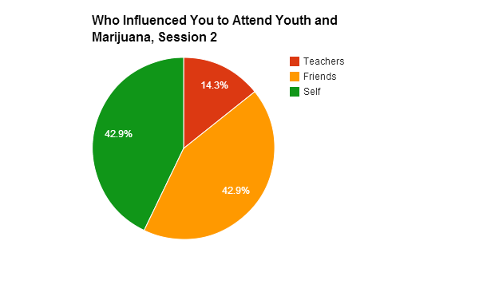
Both personal interest and other students/peers were influential by 42.9% (respectively), while teachers only influenced 14.3% of the students in Session 2.
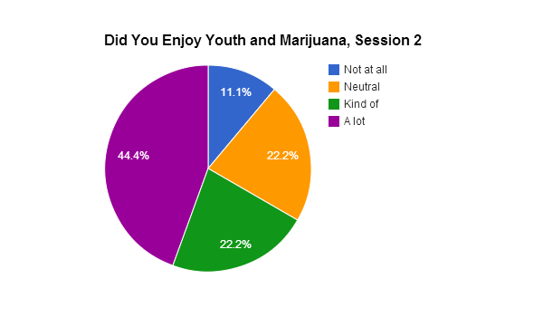
In regards to enjoyment, there were several different reactions. 44.4% said they enjoyed the session “A lot” and 22.2% said they found it only “Kind of” enjoyable, however, 22.2% were also “Neutral” on the topic and 11.1% stated “Not at all” on their survey.
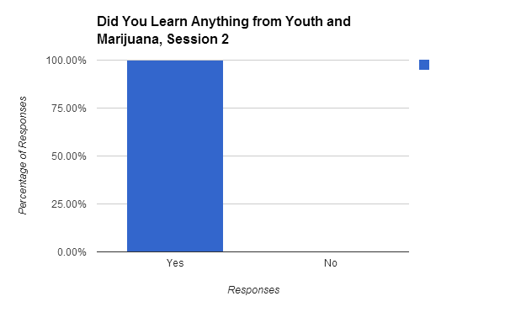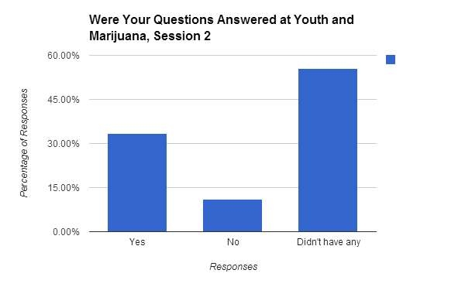
All responses stated that the session had taught them something. However, while 55.56% didn’t have any questions and 33.33% felt their questions were answered, 11.11% felt that their questions on the topic were not addressed.
Third, there were two sessions on “Bike Care.”
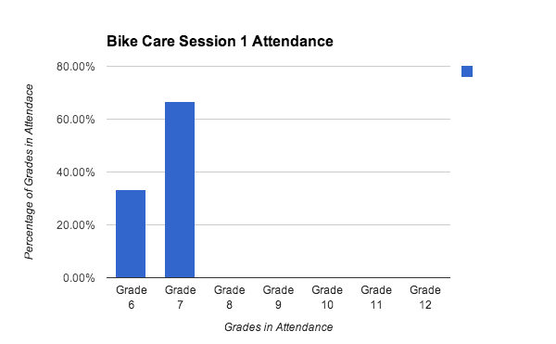
Session 1 brought in 6th graders (33.33%) and 7th graders (66.67%).
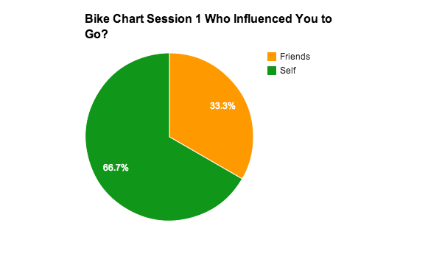
66.7% were encouraged to attend the session by friends/peers and 66.7% chose to attend out of their own curiosity.
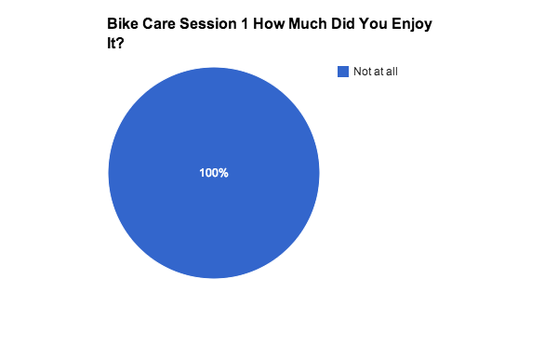
The survey shows that there was a 0% enjoyment as all respondents chose the “Not at all” option.
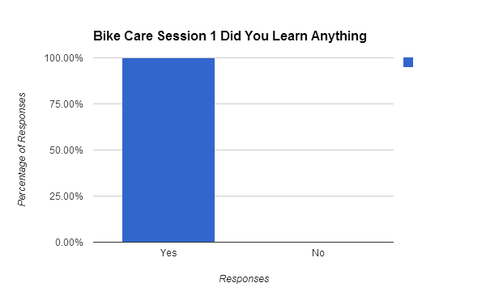
Though the enjoyment was low, all felt they had learned something from the experience.
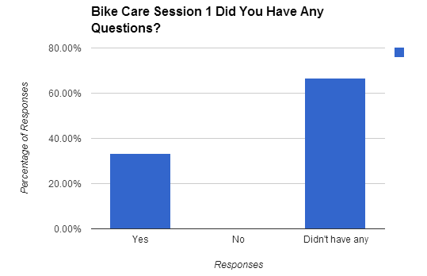
33.33% felt any questions they might have had were answered and 66.67% did not have any. There was a much different response in Session 2.
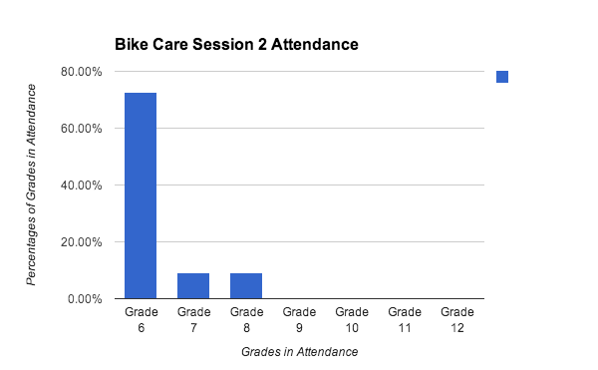
In this session, there were 6th graders (72.73%), 7th graders (9.09%), and 8th graders (9.09%). There was also one 5th grader who attended and filled out a survey. Influencers were also more diverse.
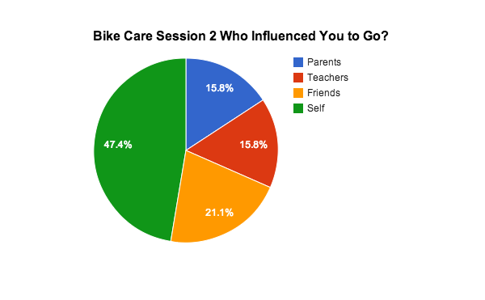
81.82% went to the session by their own choosing, 36.36% were encouraged by friends/peers, and 27.27% were influenced by parents or teachers, respectively (it is important to note that many of these students were influenced by more than one individual).
This time around, 45.45% of the attendees enjoyed the session “A lot” and 36.36% “Kind of” enjoyed it. The remaining 18.18% were divided between “Neutral” and “Slight” enjoyment.
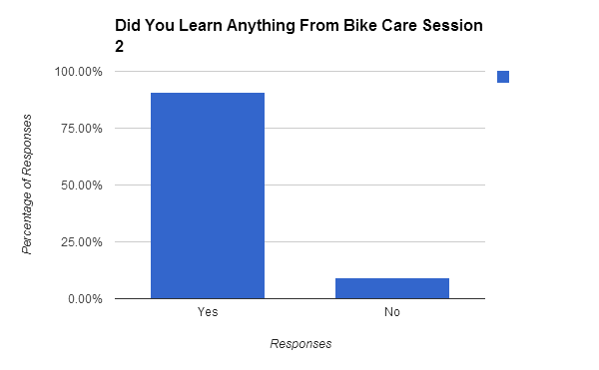
91.9% felt that they had learned something from the experience while 9.1% felt that they had learned nothing at all.
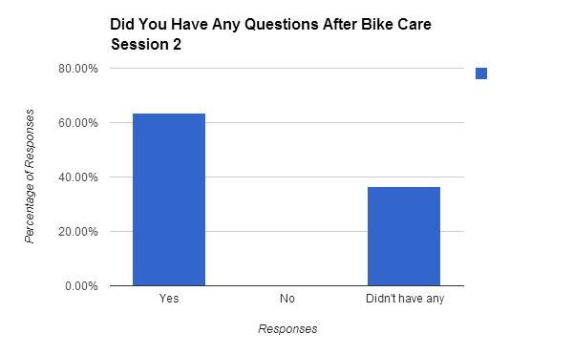
At, 63.6%, the majority of respondents felt that any questions they had were answered and 36.4% didn’t have any questions on the topic to begin with.
Finally, Shuksan Family Night had one last presentation for the youth participants: “Choose Your Path.”
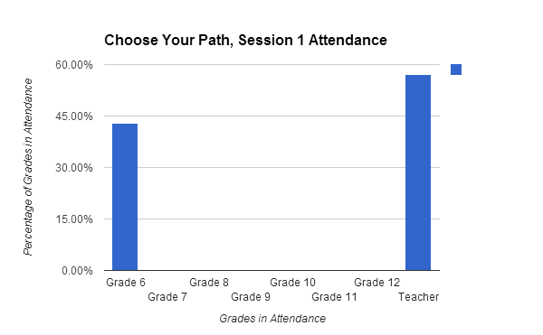
In Session 1, all youth participants were from the 6th grade and, like in “Youth and Marijuana,” a teacher also filled out an evaluation.
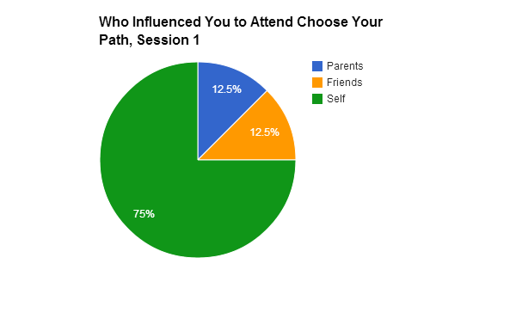
75% of the participants decided to attend out of their own curiosity, while 12,5% were influenced by parents and/or friends/peers (respectively).
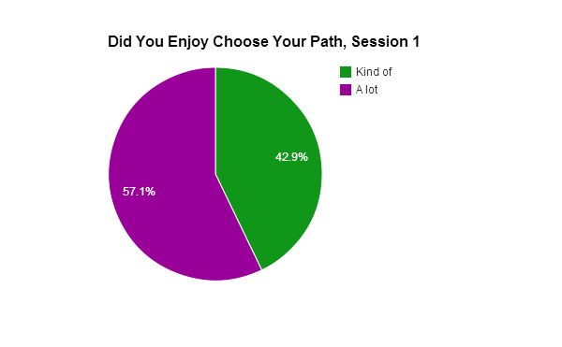
57.1% enjoyed the session “A lot” and 42.9% only “Kind of” found it enjoyable.
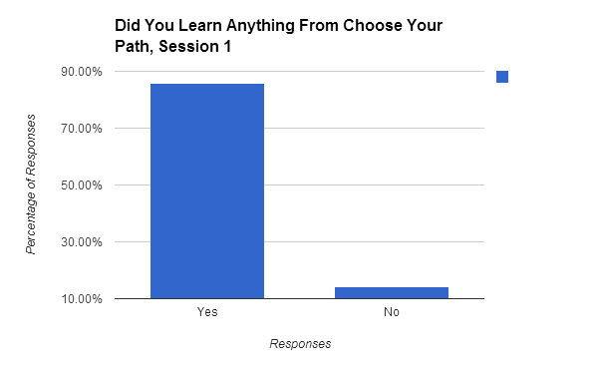
85.71% felt they walked away having learned something, however 14.29% felt that they hadn’t learned anything from the experience.
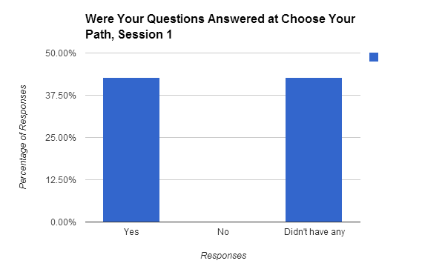
In the end, 3 students (42.86%) said that all their questions were answered and another 3 students (42.86%) said they didn’t have any questions. The remaining 14.28% did not answer that part of the survey. Session 2 garnered a bit more variety in attendees.
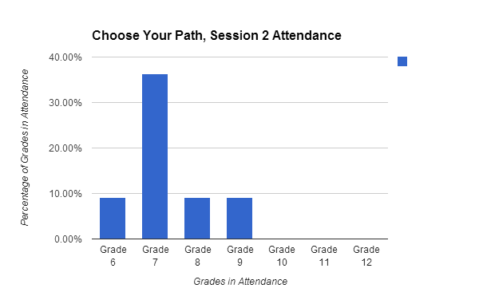
36.36% were 7th graders, 9.09% were in the 6th grade, 9.09% were in the 8th grade, and 9.09% were in the 9th grade. The remaining percent (4 attendees) did not state their grade.
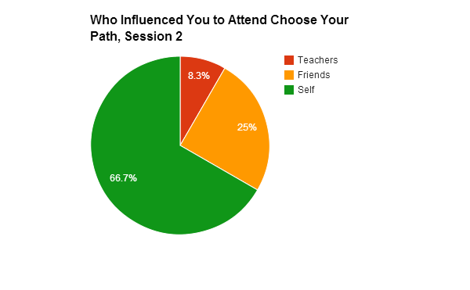
66.7% came to the session of their own accord, 25% were influenced by friends/peers, and 8.3% were encouraged by teachers.
Those that enjoyed the session “A lot” made up 45.45%, whereas 36.36% only “Kind of” found it enjoyable and 9.09% felt “Neutral” on the topic.
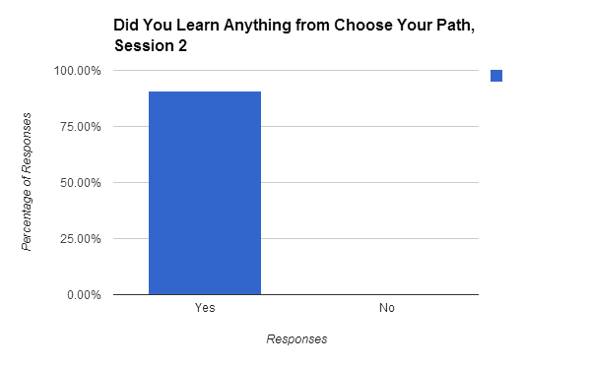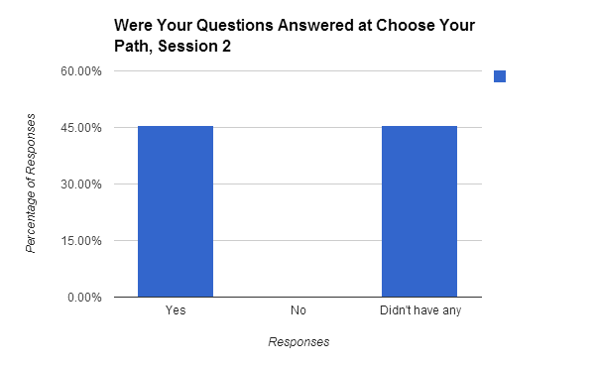
All who answered the next part of the survey (90.91%) felt they had learned something from the experience and 45.45% felt any questions they did have were answered while another 45.45% stated they had no questions.
The next part of the survey did not ask about individual sessions, but the event as a whole.
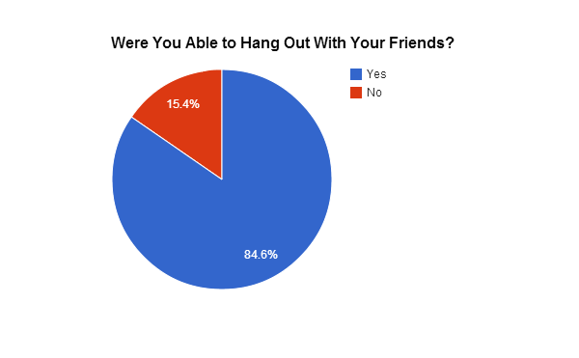
84.6% of respondents stated that they had opportunities to hang out with friends and 15.4% felt otherwise.
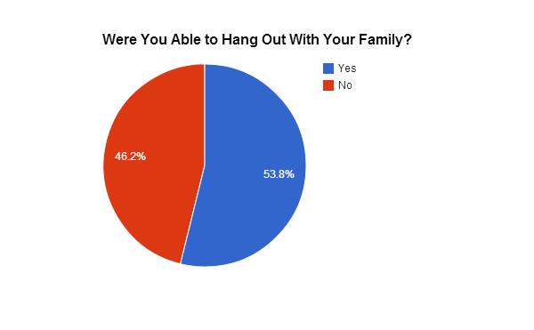
In regards to hanging out with family members, it was much more divided. 53.8% felt they had opportunities; however, 46.2% did not.
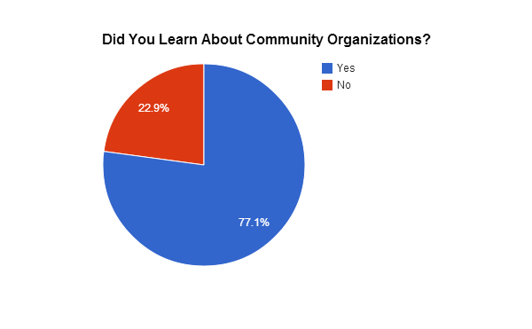
When it came to getting to learn about the different community organizations in the area, 77.1% felted they had learned something and 22.9% did not.
Finally, overall, the most enjoyable activities were the workshops (31.4%), followed by dinner (21.4%), dodgeball (20%), informational tables (14.3%), and prizes (12.9%).
Conclusion
Recommendations
After administering surveys and analyzing data, interpretations are offered to improve CFN for the following year. With strategically asked questions, surveys gave students a chance to provide feedback through various questions and a feedback questionnaire. First and foremost, to get steady, accurate, and strong data, administering surveys must be handled properly from those administering and collecting surveys. Directions from the first time the surveys are picked up from when they are dropped off are important so surveys are not lost, as well as easily organized to analyze.
According to the data collected, majority of students did not have any posed questions to ask in the sessions, and if so, very few did. “Youth and Marijuana” for example, had an average from session 1 and 2 a combined average of 56.25% of the student participants not having questions. With that, “Choose Your Path” had 45% of participants have no questions while “Bike Care” with an average of 51.25% participants having no questions. These numbers should be noted as another platform to improve CFN. Since survey’s have been tough being administered and collected the past two years, as noted in previous evaluation report, implementing a “question box” in each work session to have students write questions about the session topics so this can also be a measuring point for educators to further develop their own sessions in what best caters to the students. This can also serve as a way to see what kind of thoughts students have on “taboo” topics, such as drugs, alcohol, and violence. It can give students an opportunity to be anonymous, but have their questions be answered without being singled out, or perhaps being scared because student’s parents might find out.
Noted tremendously in volunteer observations from WWU students was the amount of distaste, negative view of cops. Volunteers went as far to say that cops wearing their uniforms were unnecessary as this can close students off from participating, having too much focus on cops, and affecting the environment of the whole goal of CFN. Because of the outlook cop uniforms can have, as students’ reaction showed and took time away from sessions, having community members like police officers not dressed in uniform, but having them dressed down with police wear that is friendlier like t-shirts that have their police branch can help students steer away from that perception. Students can see them as human beings just like them. It is important to see all positive influence from community members to create positive partnerships, as schools with higher percentages of students on free and reduced-prize lunches faces more challenges to building that positive partnership.
With strong focuses on sessions, 31.4% of students who took the surveys workshops were their favorite activity. With the incentive of receiving a ticket for an opportunity to win a prize, it is a surprise that 12.9% of students responded that the prizes were their favorite activity. Among the 5 activities, prizes were the least favorite. What can be taken away from this is workshops do indeed influence students. A more important question is: how can we keep improving workshops? As an observer in evaluating these sessions, workshops need to be guided by well-skilled facilitators who can adjust to a classroom setting with students who have high-needs that come from various backgrounds. These sessions can be fun and serious at the same time if done correctly. Having an experienced mentor who have organized, planned, and committed to these kinds of events for schools should be appointed to all who are leading sessions for these students. This will help to ensure that session leaders are prepared for student confrontation and conflict in staying active in sessions.
Limitations
The biggest limitation this evaluation team had was in the data collection process. When handing out the surveys, the participants were told that if they returned the surveys after they were filled out, they would receive an extra raffle ticket. The evaluation team and the stakeholders hoped this would create enough incentive for participants to fill out and turn in the surveys, but they found that many surveys were not returned. This does not allow for highly accurate data because the data shown does not represent everybody who attended.
The data collection process was also slightly disorganized, which created a bit of a mess in trying to obtain all possible surveys. One of the data collectors recycled what she thought were unused surveys, but later realized that they were all the surveys for that session. The evaluation team was unable to re-obtain all the surveys that were accidently thrown out, and most of the data for that session is missing.
Another problem we ran into was that for the Embrace Your Identities workshop, there were no Session 1 surveys. The evaluation team member in that workshop instructed participants to fill out the front side of the Session 2 surveys. However, these surveys either went missing, or participants misunderstood instructions and filled out both sides. When the evaluation team member in charge of coding the surveys was coding, she was not aware of this issue and was not able to catch which surveys were meant for session 1 and which ones were meant for session 2. This makes both sessions for this workshop less accurate.
Lessons Learned
This evaluation overall takes a good amount of coordination for everyone involved, especially for those involved in data collection. This evaluation team was not fully aware of the amount of coordination it would take. Those that were recruited to assist in the distribution and collection of surveys were not properly briefed on what needed to be done to ensure that the data collection would be as accurate as possible. None of the surveys should have been thrown away, and we should not have run out of surveys. Something to keep in mind for future evaluation teams is that communication is very important during the data collection process; there should be a team member in charge who can oversee that each workshop gets the correct number of surveys, each data collection assistant is properly briefed, and can collect all surveys after the event. This should make data collection easier and more accurate in the future.

Appendix A
Session 1 Survey; Session 2 Front Page
Session 1 or 2 Grade: ____
We want your feedback! Please take a moment to fill out this survey. Your feedback will be used to improve next year’s Community Family Night. Thank you for your participation!

Which workshop is this?
☐ Youth and Marijuana: What road will you take? ☐ Getting Around Town: Bike & Bus-Riding Tips
☐ Choose Your Own Path ☐ Embrace Your Identities/Aprecia Tus Identidades
Why did you go to this workshop? Check all that apply.
☐ Parent(s) wanted me to ☐ Friend(s) wanted me to
☐ Teacher(s) wanted me to ☐ I wanted to
Did you enjoy this class? O O O O O
Not at all Kind of Absolutely
Did you learn something new? ☐Yes ☐ No
Were your questions answered? ☐ Yes ☐ No ☐ I had no questions

Appendix B
Session 2 Survey (Back page; see Appendix A for front page)

We want to know how well the entire night went! Please take a moment to fill out the second part of the survey. Your feedback is very much appreciated and important for improving next year’s event. We thank you for attending!

Did you enjoy this class? O O O O O
Not at all Kind of Absolutely
Were you able to hang out with your friends? ☐Yes ☐ No
Were you able to hang out with your family? ☐Yes ☐ No
Did you learn about any community organizations? ☐Yes ☐ No
What were your favorite activities? Check all that apply.
☐ Workshops ☐ Raffle ☐ Dinner
☐ Dodgeball ☐ Community Information Booths
What was your favorite topic?
What would you like to see next year?

Appendix C
Session 1 Surveys for Embrace Your Identities

Appendix D
Session 2 Surveys for Embrace Your Identities

Appendix E
Session 1 Surveys for Youth and Marijuana

Appendix F
Session 2 Surveys for Youth and Marijuana

Appendix G
Session 1 Surveys for Bike Care

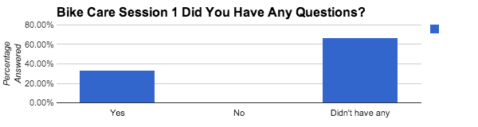

Appendix H
Session 2 Surveys for Bike Care

Appendix I
Session 1 Surveys for Choose Your Path

Appendix J
Session 2 Surveys for Choose Your Path

Appendix K
Overall Event Surveys

References
Marques, S., Lopez, S., & Pais-Ribeiro, J. (2011). Building hope for the future: A program to foster strengths in middle-school students. Journal of Happiness Studies 12(1), 139-152. doi: 10.1007/s10902-009-9180-3
O’Donnell, L., Stueve, A., San Doval, A., Duran, R., Haber, D., Atnafou, R. . . . Piessens, P. (1999). The effectiveness of the reach for health community youth service program in reducing early and unprotected sex among urban middle school students. American Journal of Public Health 89(2), 176-181.
Office of Superintendent of Public Instruction. (2013). Shuksan middle school. Washington State report card. Retrieved from: http://reportcard.ospi.k12.wa.us/summary.aspx?groupLevel=District&schoolId=3046&reportLevel=School&orgLinkId=3046&yrs=2012-13&year=2012-13
Snyder, C. R., Hoza, B., Pelham, W. E., Rapoff, M., Ware, L. . . . Danovsky, M. (1997). The development and validation of the Children’s Hope Scale. Journal of Pediatric Psychology 22, 399–421.

