Lauren Milne
EDUC 301
Paula Dagnon
17 April 2011
Multimedia Assign. #1
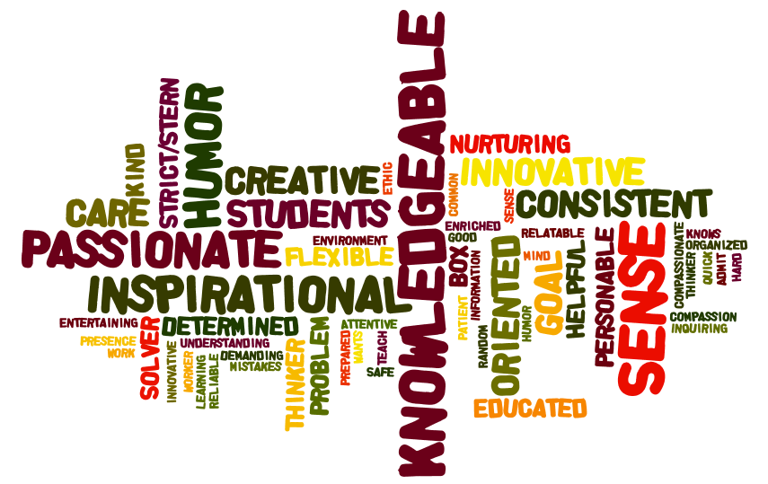

After conducting my survey on “5 Characteristics of Effective Teachers”, I found that having Knowledge, a Sense of Humor, a Passion for Education, being Inspirational, and Innovation were the top five most favored aspects. As we had seen on Slide 6 of the “Excellent Teacher” PowerPoint in class, Knowledge was the top contender for becoming an excellent teacher. The individuals I asked this question to were all contacted through Facebook and they ranged from 13-60 years old, male and female. Each of the individuals were either still in school as students or had worked as educators themselves. Though the way they worded their answers varied on age and occupation, the answers were still all the same. It would seem, based upon these results and research conducted elsewhere, that you have to first be knowledgeable on your subject in order to be able to display your passion for the subject appropriately and once you can achieve that with a sense of humor, you become inspirational to your students and they can learn effectively from your innovative/engaging method of teaching.

